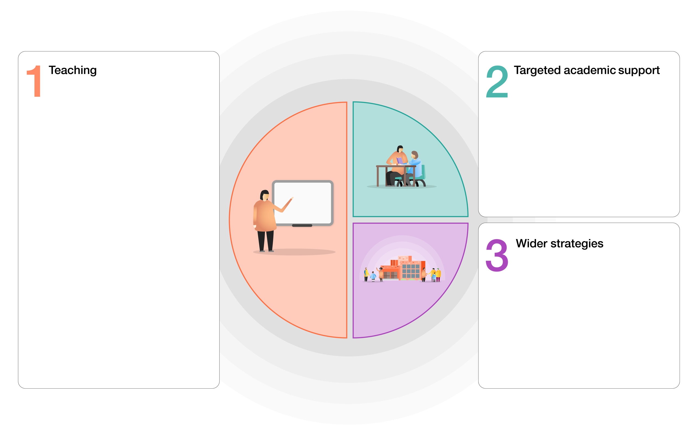

**Rudgwick Primary School**

* Continued use of Google Classroom
* High expectations set upon return – new books, new labels
* Letter join – handwriting
* Attendance – dedicated time for tracking daily
* ELSA – timetabled support
* Mental health return to school questionnaires
* NELI (early language intervention) training & targeted groups
* Narrative therapy
* Year 6 maths group
* Phonics tutoring 1:1
* Clicker 8 to support writing
* Quality First Teaching
* New bespoke curriculum specific to our pupils. KPIs identified.
* Standardised whole school assessment – PIRA, PUMA, PTMS, SWST, book banding, RWI phonics tests, teacher assessment on target tracker.
* CPD – wellbeing, mindful training, breathing, calming & grounding strategies.
* Metacognition & self-regulation with a focus on DA INSET.
* Google classroom
* Disadvantaged lead training – SN.
* Clicker 8
* Raising profile of fluency - Number bonds challenge
* Accelerated Reader